**MST 1102- Introduction to Statistics WkSheet 2**

**(Last Name, First Name): ______________________________________________________________**

**Data, Terms used in Statistics**

1. Consider the following scenarios and determine whether the data is qualitative, quantitative discrete or quantitative continuous. **[3 marks]**
2. Human Blood Types- Human beings have one of four blood types: A, B, AB, or O. What kind of data do you receive when you are told your blood type? ________________________________________________________________________
3. Household Size- The U.S. Census Bureau collects data on household size and publishes the information in Current Population Reports. What kind of data is the number of people in your household? _________________________________________________________________________________
4. The World’s Highest Waterfalls- The Information Please Almanac lists the world’s highest waterfalls. The list shows that Angel Falls in Venezuela is 3281 feet high, or more than twice as high as Ribbon Falls in Yosemite, California, which is 1612 feet high. What kind of data are these heights? ___________________________________________
5. In the Born Loser cartoon strip by Art Sansom, Brutus expresses joy over an increase in temperature from 1℃ to 2℃. When asked what is so good about 2℃, he answers that “it’s twice as warm as this morning.” Explain why Brutus is wrong yet again. **[2 marks]**

**_____________________________________________________________________________________________________________________________________________________________________________________________________________________________________________________________________________________________________________________________________________________________________________________________________________________**

1. Provide a reason why classifying data by different measurement scales is important. **[1 mark]**

______________________________________________________________________________________________________________________________________________________________________________________________________________________________________________________________________________

1. Determine which of the levels of measurement (nominal, ordinal, interval, ratio) is most appropriate. **[4 marks]**
2. The Voltage measured from Dale’s home was found to be 123.7 volts.
3. Types of movies (drama, comedy, adventure, documentary).
4. Critic ratings of movies on a scale from 0 star to 4 stars.
5. The years of release of five movies.
6. State whether the scenario below describes low/high precision and/or low/high/accuracy.
7. The outside temperature is $23℃$ and the thermometer records the temperature for five days as $23℃, 22.8℃, 23.1℃, 23℃, 22.9℃$. __________________________________________________________________________ **[2 marks]**

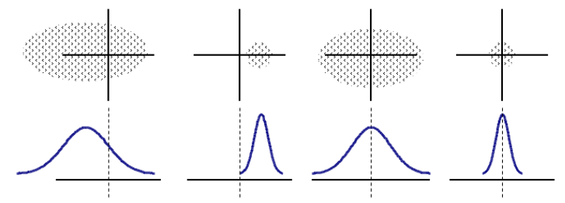

1. Which graph on the right represents
2. High accuracy but low precision? **[1 mark]**
3. Low accuracy but high precision? **[1 mark]**

Items 7-9 are multiple choice based. Each question is worth 1 mark **[3 marks]**

1. A survey will be given to 50 students selected at random from the 5th form class of a school. What is the population?

A. The 50 selected students.

B. All students in 5th form.

C. All students at the school.

1. A survey will be given to 50 students selected at random from the 5th form class of a school. What is the sample?

A. The 50 selected students.

B. All students in 5th form.

C. All students at the school.

1. A mean could be a

A. Statistic.

B. Parameter.

C. Statistic or Parameter.

1. What is the purpose of replicating the experimental condition in a study? **[1 mark]**

_______________________________________________________________________________________________________________________________________

1. State two reasons why it may be necessary to use a sample rather than an entire population. **[2 marks]**

Reason 1: ____________________________________________________________________________________________________________________________

Reason 2: ____________________________________________________________________________________________________________________________

1. Why is it important for a sample to be selected from a population at random? **[2 marks]**

__________________________________________________________________________________________________________________________________________________________________________________________________________________________________________________________________________________________________________________________________________________________________________________________________________________

1. State two ways in which a researcher may select items at random from a population of interest to be included in a sample. **[2 marks]**

Reason 1: ____________________________________________________________________________________________________________________________

Reason 2: ____________________________________________________________________________________________________________________________

1. A statistical study is presented for the questions below. Identify both the parameter and statistic for each study. The first two will be done for you as examples. **[4 marks]**
2. A researcher wants to estimate the average height of women aged 20 years or older. From a simple random sample of 45 women, the researcher obtains a sample mean height of 63.9 inches.

Statistic: ________________________________________________________________________________________________________________________

Parameter: _____________________________________________________________________________________________________________________

1. A sociologist wants to estimate the proportion of adults with children under the age of 18 that eat dinner together 7 nights a week. A simple random sample of 1122 adults with children under the age of 18 was obtained, and 337 of those adults reported eating dinner together with their families 7 nights a week.

Statistic: ________________________________________________________________________________________________________________________

Parameter: _____________________________________________________________________________________________________________________

1. An energy official wants to estimate the average oil output per well in the United States. From a random sample of 50 wells throughout the United States, the official obtains a sample mean of 10.7 barrels per day.

Statistic: ________________________________________________________________________________________________________________________

Parameter: _____________________________________________________________________________________________________________________

1. Nexium is a drug that can be used to reduce the acid produced by the body and heal damage to the esophagus. A researcher wants to estimate the proportion of patients taking Nexium that are healed within 8 weeks. A random sample of 224 patients suffering from acid reflux disease is obtained, and 213 of those patients were healed after 8 weeks.

Statistic: ________________________________________________________________________________________________________________________

Parameter: _____________________________________________________________________________________________________________________

1. Selecting the proper diet for shrimp or other sea animals is an important aspect of sea farming. A researcher wishes to estimate the mean weight of shrimp maintained on a specific diet for a period of 6 months. One hundred shrimp are randomly selected from an artificial pond and each is weighed.
2. Identify the population of measurements that is of interest to the researcher. **[1 mark]**

______________________________________________________________________________________________________________________________

1. Identify the sample. **[1 mark]**

______________________________________________________________________________________________________________________________

1. What characteristics of the population are of interest to the researcher? **[1 mark]**

______________________________________________________________________________________________________________________________

1. If the sample measurements are used to make inferences about certain characteristics of the population, why is a measure of the reliability of the inferences important? **[1 mark]**

______________________________________________________________________________________________________________________________

**Total: 32 marks**